**Difference between CloudWatch log and CloudWatch metric**

CloudWatch Logs: CloudWatch Logs is a service that helps us to collect, store, and analyze log files generated by the applications and AWS services. It allows us to search, filter, and gain insights from log data, enabling us to troubleshoot issues, monitor application behavior, and ensure compliance.

Example: Imagine we have a web application running on AWS. With CloudWatch Logs, we can gather and store all the log files generated by our application, such as error logs or access logs. This allows us to easily search for specific log events, identify and fix errors, and understand how users interact with the application.

Implementation:

1. Install and configure the CloudWatch Logs agent on our EC2 instances.
2. Define a log group to store log data.
3. Configure log streams within the log group to organize and separate log data based on different sources or applications.
4. Start streaming logs from the applications or services to the appropriate log streams.
5. Use CloudWatch Logs Insights to analyze and query your log data.
6. Set up CloudWatch Alarms to monitor specific log events and trigger actions based on predefined conditions.

**SAMPLE**

Process to create log:

1. Launch an instance
2. configure IAM role with policies of cloudwatchfullaccess

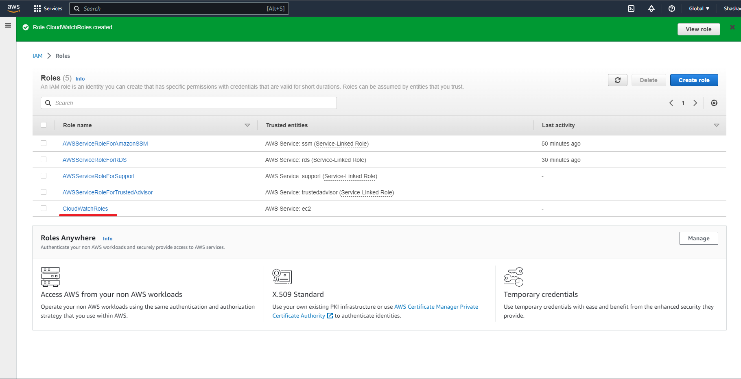

1. Add this IAM Role into Instance

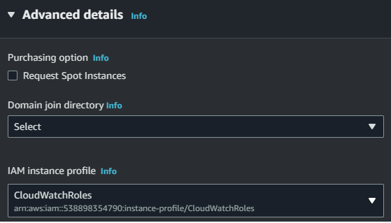

To Check the polices

Click the IAM Role link

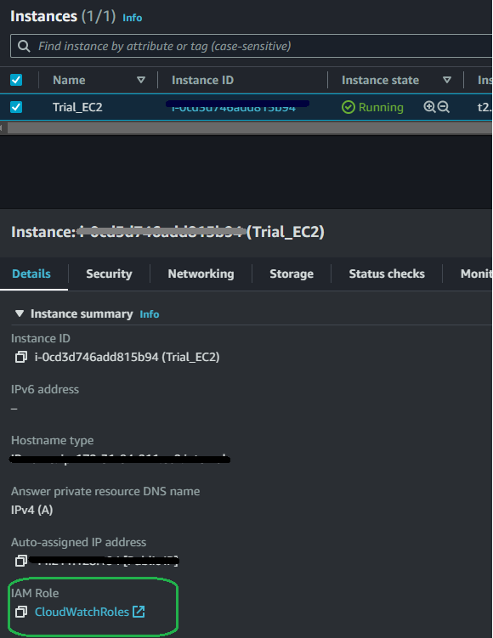

This is Interface look where defined all logs are permitted

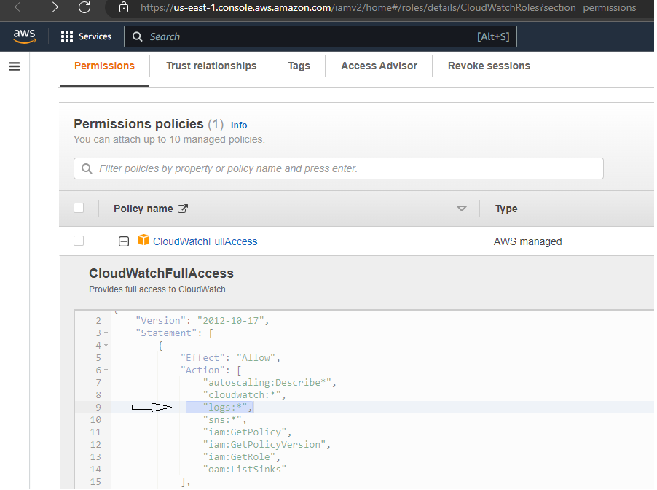

1. Finally launch the instance, wait for a while initialise it.
2. Now using ssh start using CLI mode ec2 instance

Vi . Next check update command- sudo yum update –y

Vii. Again run a command- sudo yum install amazon-cloudwatch-agent –y

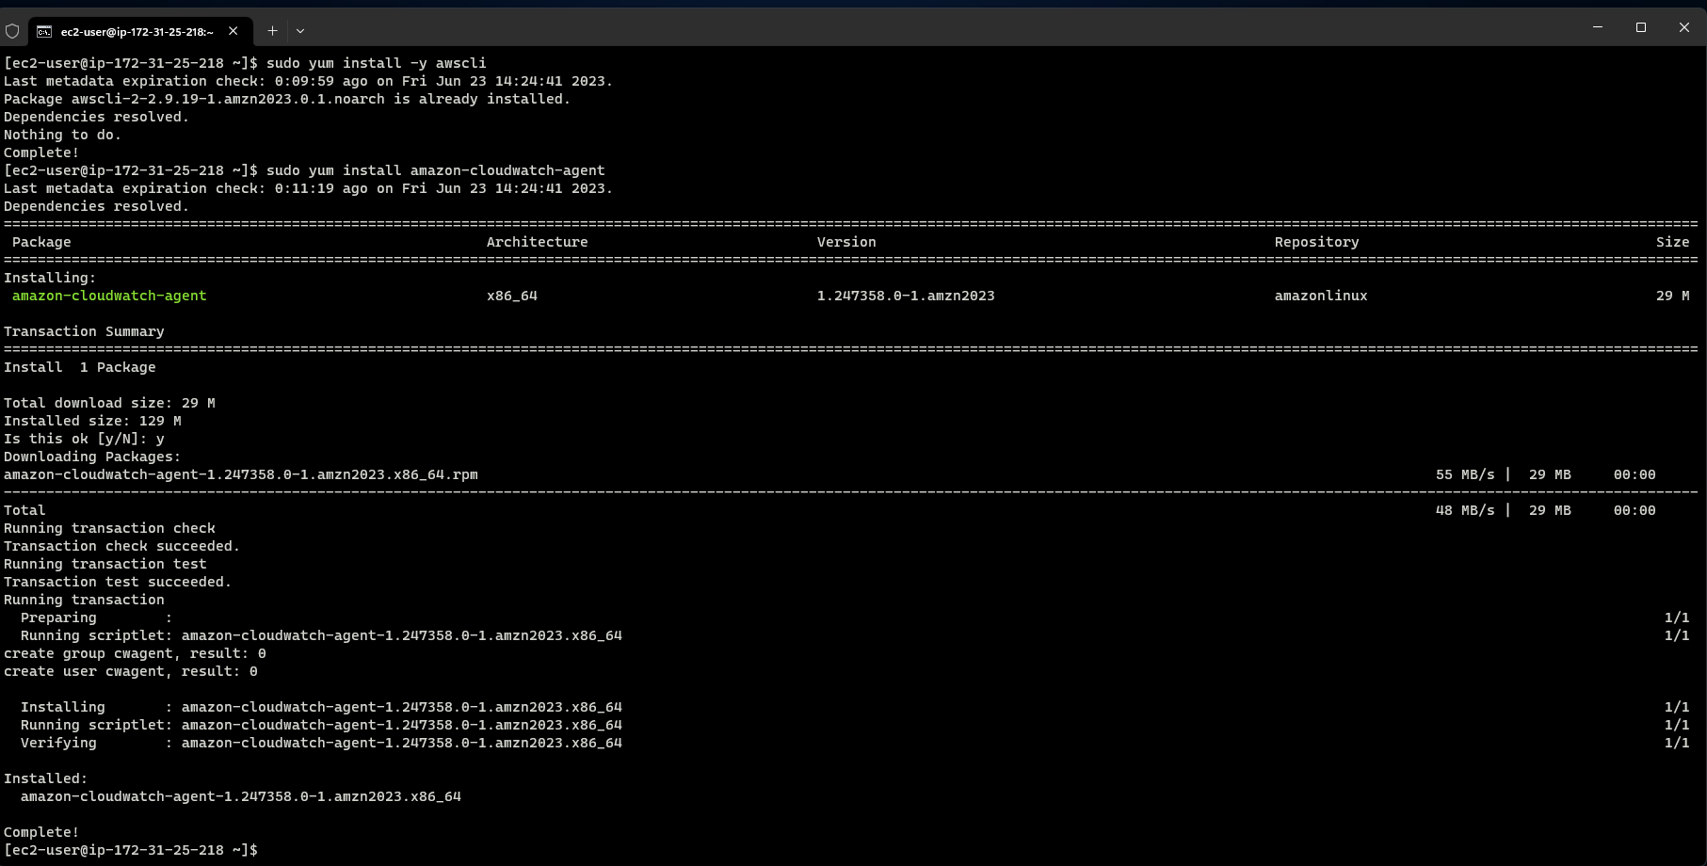

Viii. Next command is to run to start the agents - /opt/aws/amazon-cloudwatch-agent/bin/ amazon-cloudwatch-agent-config-wizard

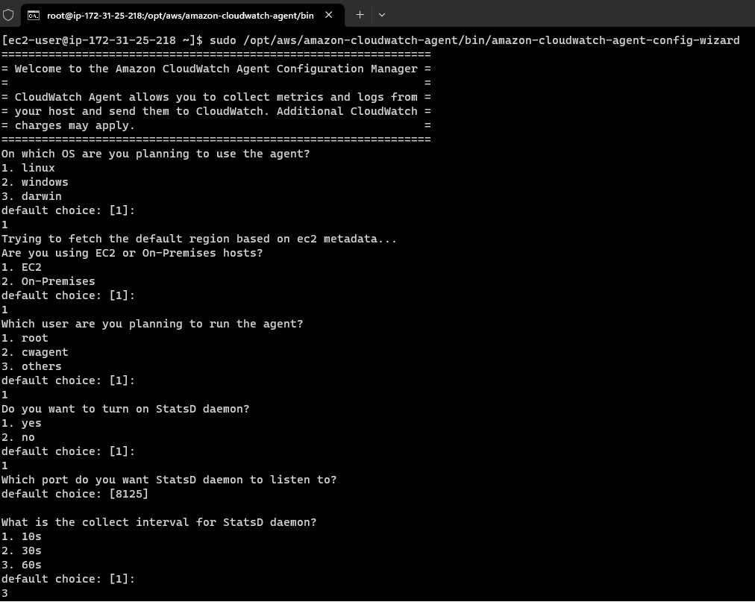

Here are some processes by which it will create json file according to user choice (in most of the case it will default).

Now a commad to start the agent using created json file - sudo /opt/aws/amazon-cloudwatch-agent/bin/amazon-cloudwatch-agent-ctl -a fetch-config -m ec2 -s -c file:/opt/aws/amazon-cloudwatch-agent/bin/config.json

Command run successfully

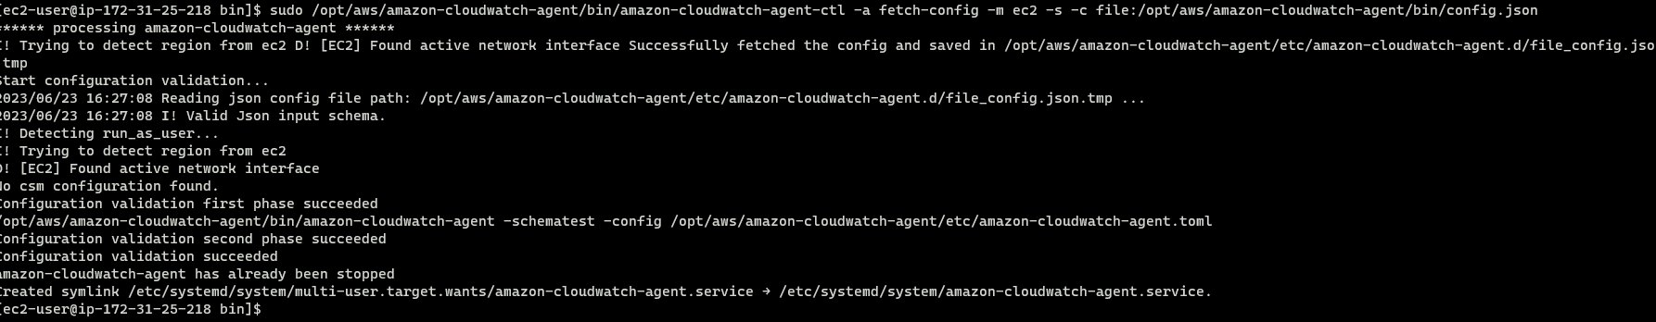

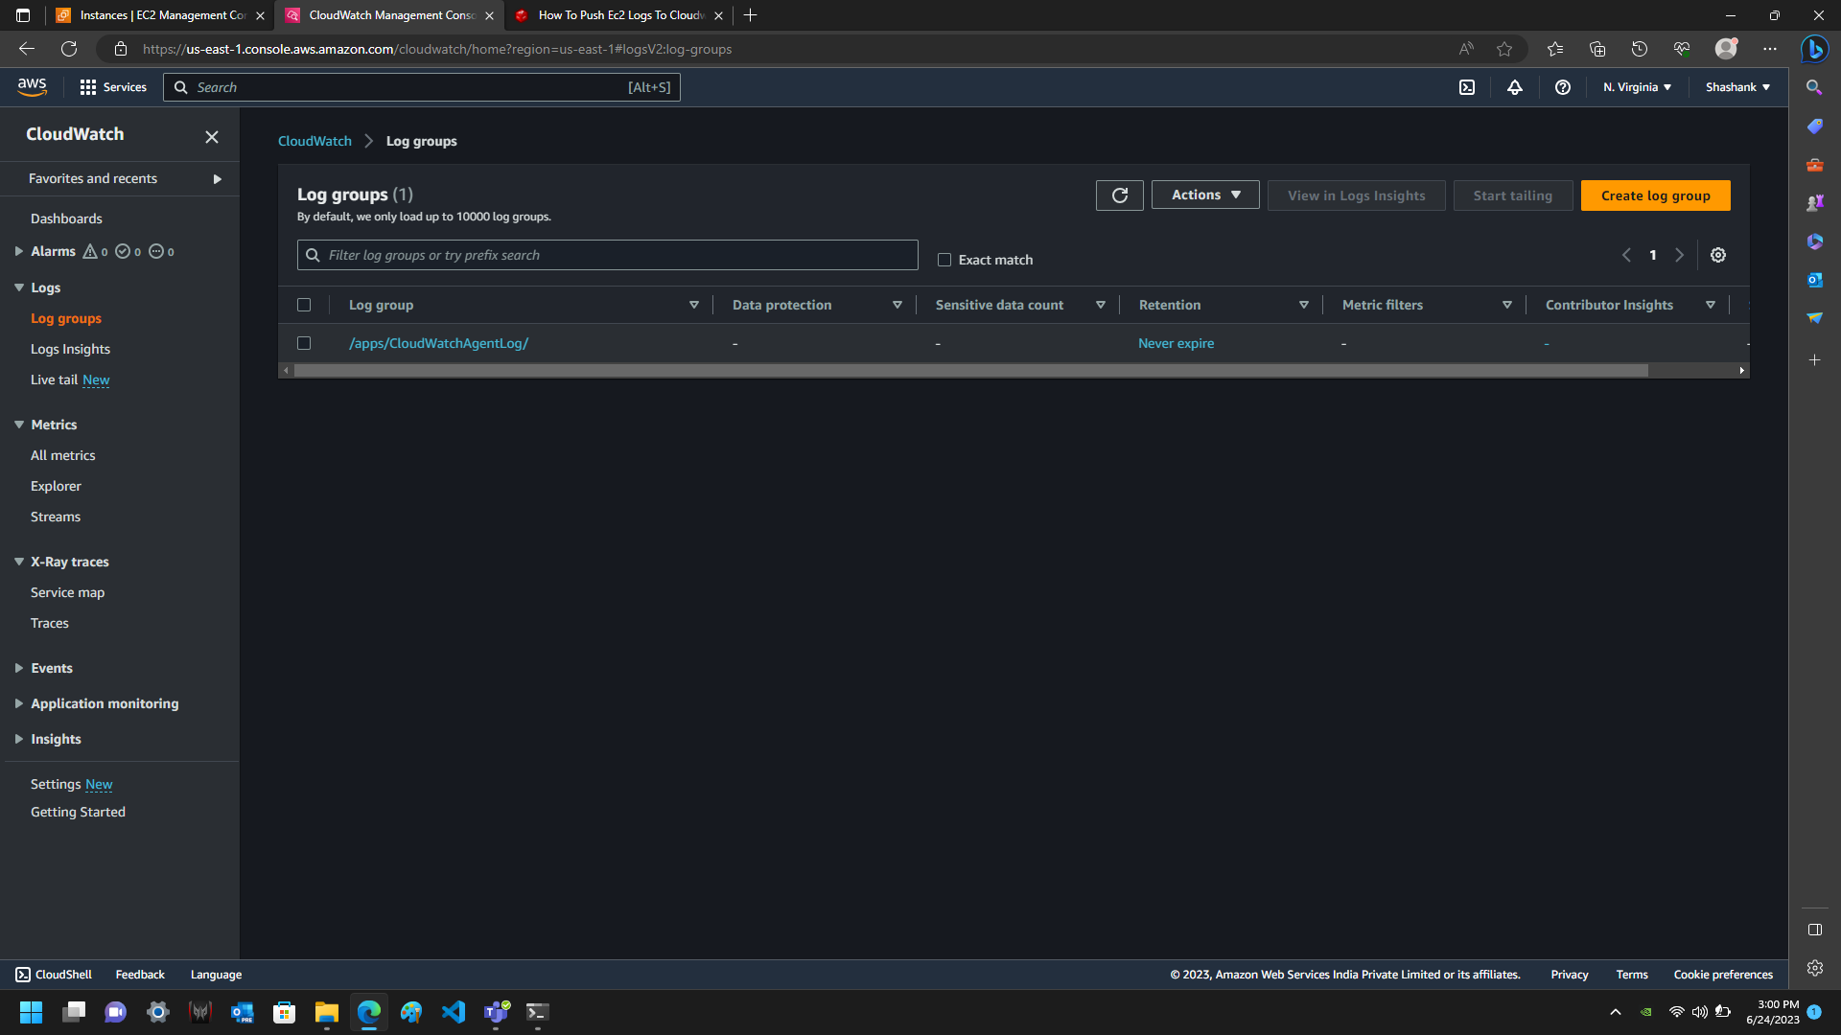Log has been created

Get inside this log group this is named with my instance id

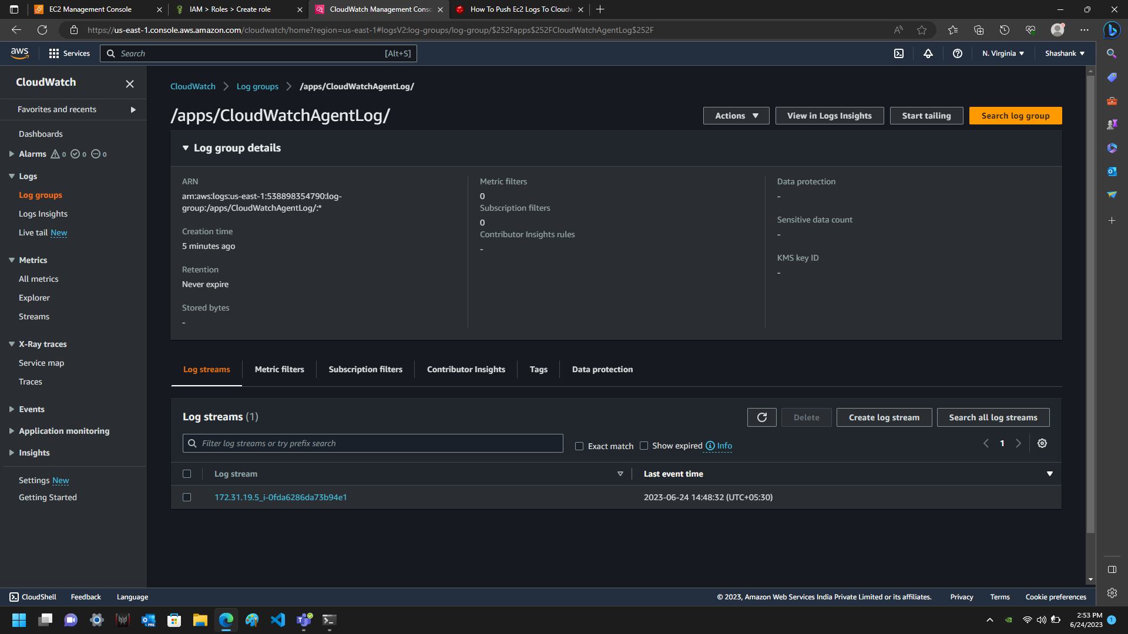

If I click to watch inside log stream then these are events trace every signal

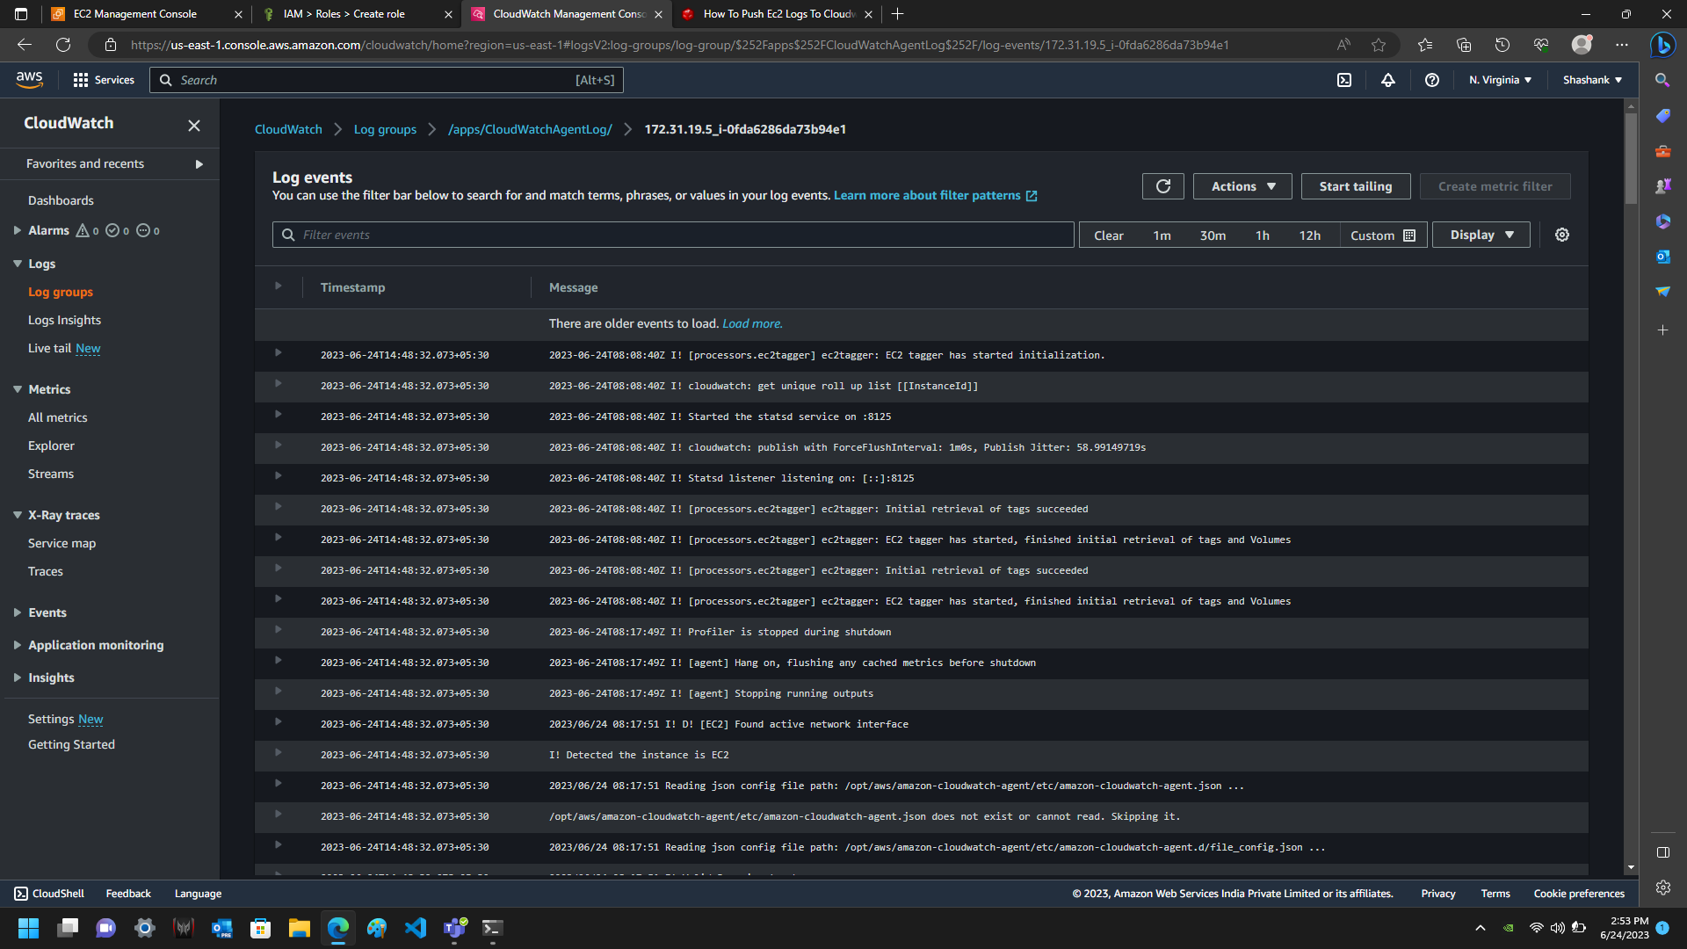

CloudWatch Metrics: CloudWatch Metrics provides detailed monitoring data for all our AWS resources and applications. It gives a visibility into various performance indicators and metrics, such as CPU utilization, network traffic, or request latency. We can track these metrics over time, set alarms based on specific thresholds, and take actions accordingly.

Example: Assume we have a fleet of EC2 instances hosting a web service. With CloudWatch Metrics, we can monitor metrics like CPU usage or network throughput for each instance. By analyzing these metrics, we can ensure that our instances are properly sized, identify any performance bottlenecks, and receive alerts if certain metrics exceed predefined thresholds.

Implementation:

1. Identify the AWS resources or services for which we want to monitor metrics.
2. Enable metric collection for the desired resources or services. Many AWS services automatically
3. publish metrics to CloudWatch, while others require additional configuration.
4. Use the CloudWatch console, AWS CLI, or SDKs to view and analyze the collected metrics.
5. Create dashboards to visualize metrics and create custom views.
6. Set up alarms based on specific metric conditions to receive notifications or trigger automated actions.

**SAMPLE**

On the basis of all above process we have create metric of Our created EC2 instance

Now we have to just go to Metric section in same cloudwatch console

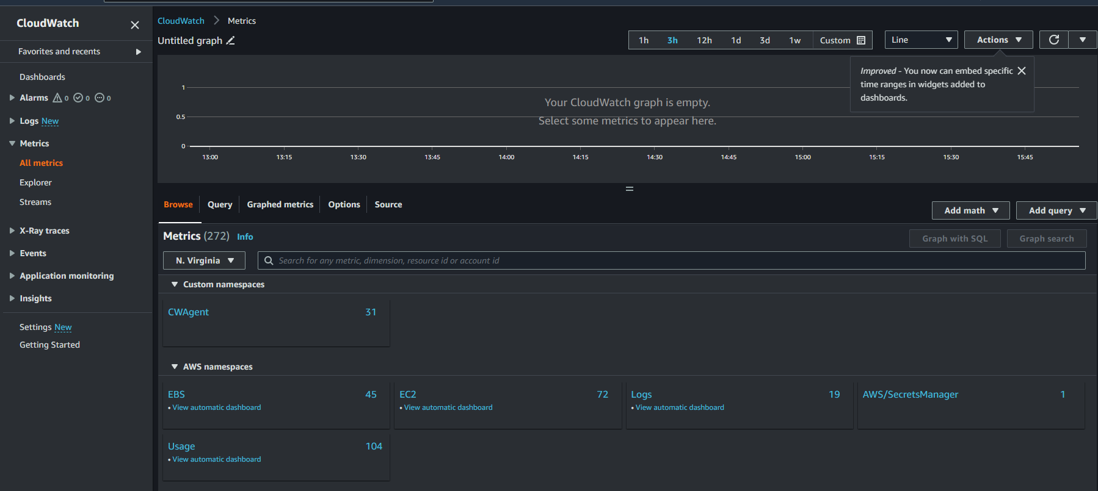

Click on CWAgent:

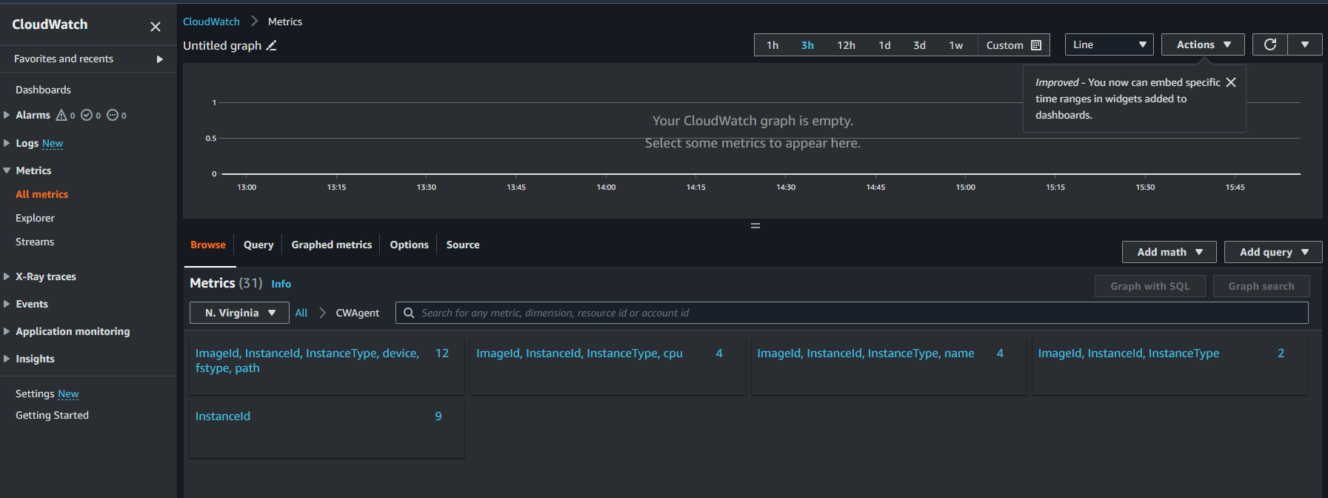

Click any of block click on ImageId,InstanceId.......path

Monitor on each and every resource that is used by EC2 instance(apply filter to look usage particular time period)

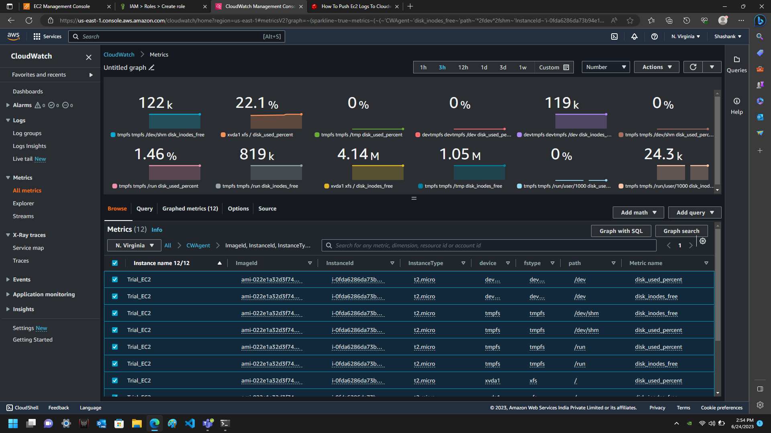

Reference link:

aws-cloudwatch-agent

[Learn how to install AWS CloudWatch Agent on an EC2 instance - YouTube](https://www.youtube.com/watch?v=U7X3ehGZYwQ)

[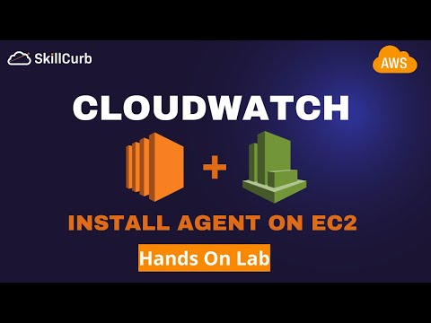](https://www.youtube.com/watch?v=U7X3ehGZYwQ)

Using deprecated method –awslogs

[Quick Start: Install and configure the CloudWatch Logs agent on a running EC2 Linux instance - Amazon CloudWatch Logs](https://docs.aws.amazon.com/AmazonCloudWatch/latest/logs/QuickStartEC2Instance.html)

[CloudWatch Logs for EC2 Tutorial - YouTube](https://www.youtube.com/watch?v=ZCHwJLqPLj8)

[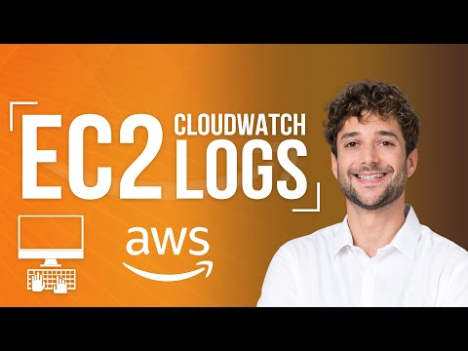](https://www.youtube.com/watch?v=ZCHwJLqPLj8)